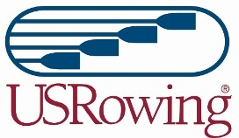

USRowing Committee Commitment Form
(The information provided on this form will be included with balloting materials.)
Name: ________________________________________________________________

Address: ______________________________________________________________

City: ___________________________ State: ____________ Zip: ______________

Organizational Affiliation: ___________________________ Phone: ____________

USRowing Member Number: ____________________ Birthdate: ______________

E-mail: ________________________________
LinkedIn Profile or Resume URL (You also may attach a resume to your application email.): _____________________________________________________________

E-mail:

Athlete Representative High Performance Committee

Athlete Representative Para High Performance Committee
Attestation: I have reviewed the qualifications, charges, and responsibilities of the position that I am seeking as outlined in the USRowing Bylaws, SafeSport policy manual, and Committee Charters and affirm that I am qualified to serve and committed to fulfill the responsibilities of the position that I seek.

Signature of Candidate: Date:

Please provide a response to the following questions:

- How will you work to add relevance to USRowing through your work as a committee member?

- What skills, experience, and/or perspective would you bring to the High Performance Committee or Para High Performance Committee?

- What added value do you bring that separates you from other candidates in shaping the future of our sport.

Materials must be received (NOT postmarked) by Friday, November 21, 2025.

Return this Nomination Form to:

USRowing – Elections
members@usrowing.org

